

Project Title: INTERNMENT

**1.0 INTRODUCTION**

The Internment (Campus Placement Management System) is an online platform that aims to streamline the campus placement process for students and college TPOs. It provides an easy and efficient way for students to search and apply for job opportunities, and for college TPOs to post job details and monitor the placement process. The system also allows students to upload their resumes and there past education details.

In this project, we aim to develop a web-based application that provides a seamless and user-friendly experience for students and college TPOs. The system will be designed to ensure the security and confidentiality of user information, with access restricted to authorized users only. It will be implemented using various web technologies such as HTML, CSS, JavaScript, PHP, and MySQL.

* 1. **PROJECT SCOPE**

The scope of the project includes the development of a Campus Placement Management System that allows students to create an account, view available job opportunities, build their resumes, and apply for jobs. College TPOs can post job details and monitor the placement process. The system will have features such as user registration, job search, job listing, job posting, and placement history.

In conclusion, the Campus Placement Management System will provide a reliable and efficient platform for managing the campus placement process for colleges and students. It will streamline the job search and application process for students, and make it easier for college TPOs to manage the placement process. The project scope includes various features and technologies, and will be implemented and tested to ensure its reliability and efficiency.

**System features:**

1. User Registration: The system shall allow students to create an account with their details and select their respective college.
2. User Login: The system shall allow users to login with their registered email and password.
3. Job Search(Pending): The system shall allow students to search for job opportunities based on various criteria such as company, job profile, and location.
4. Job Listing: The system shall display the list of available jobs along with job description, eligibility criteria, and salary.
5. Apply for Job: The system shall allow students to apply for jobs by submitting their resumes and other required details.
6. Job Posting: The system shall allow college TPOs to post the job details including job description, eligibility criteria, and salary.
7. Job Shortlisting(Pending): The system shall allow college TPOs to shortlist the candidates based on their eligibility criteria.
8. Placement History(Pending): The system shall maintain a history of past applied jobs for the students.

**2.0 DESIGN**

2.1 Business Use case:

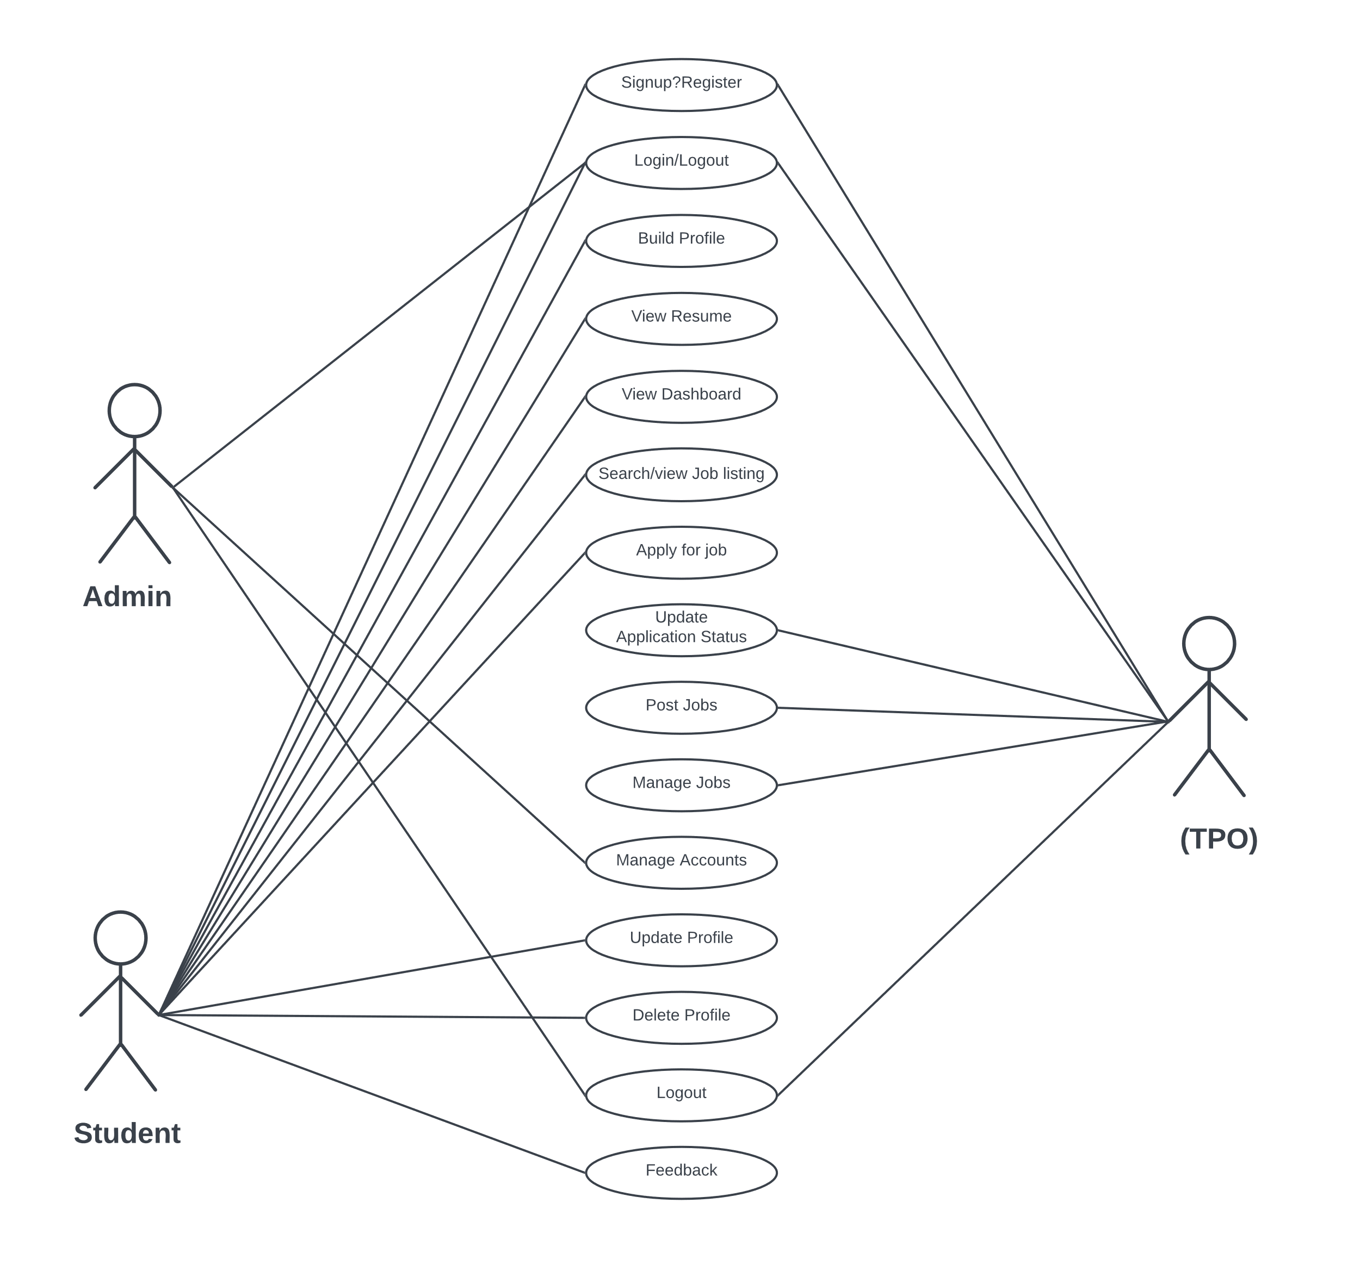

2.2 Class diagram :

2.3 Database Design:

Database Structure:

Company Table:

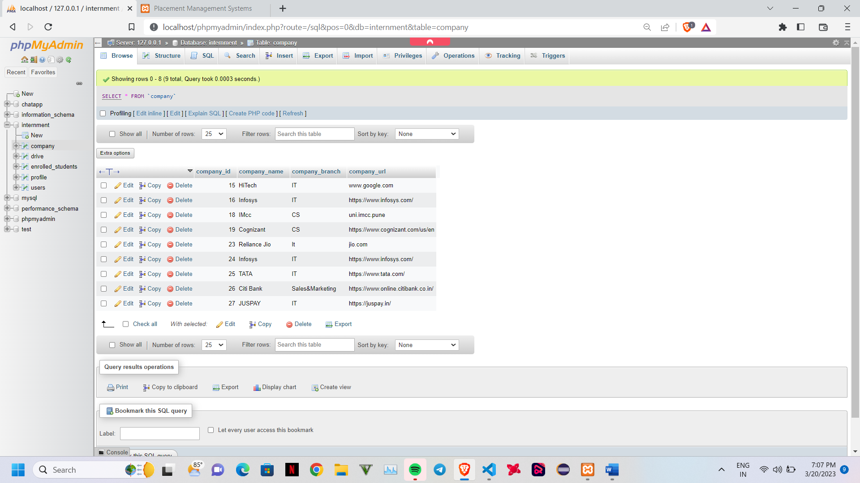

Drive table:

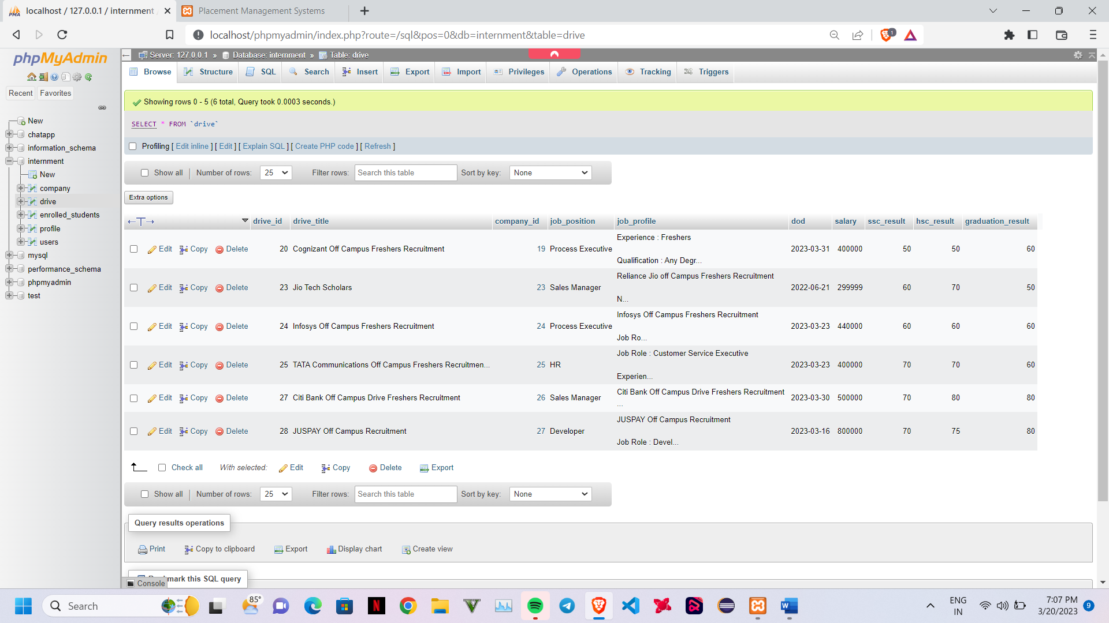

Enrolled_students:

Profile:

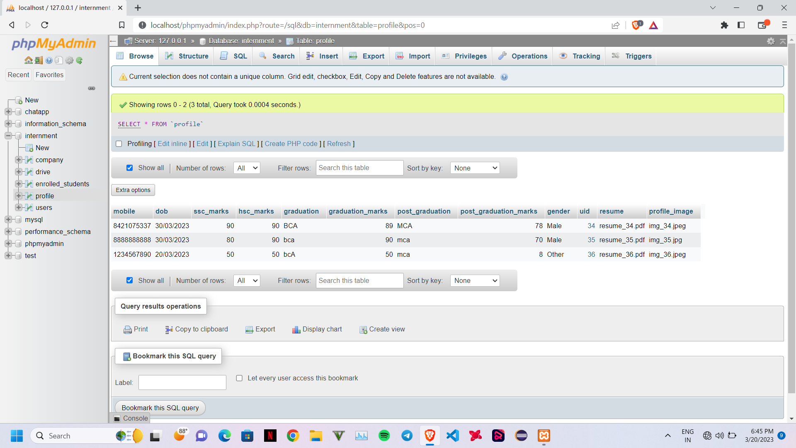

Users:

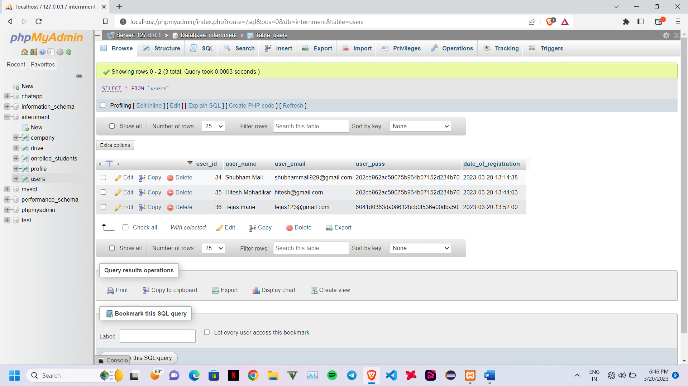

**3.0 User Interface**

User Registration:

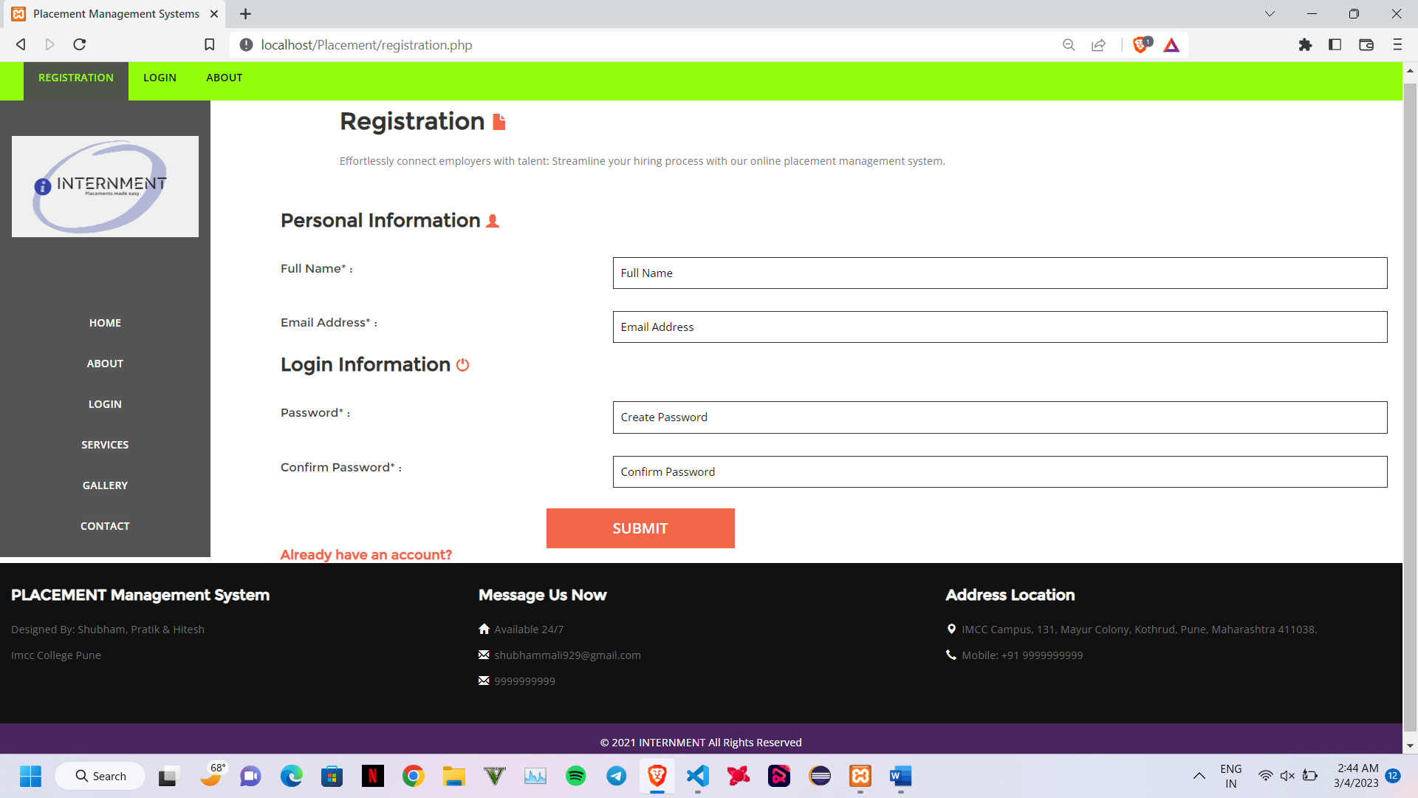

User Login:

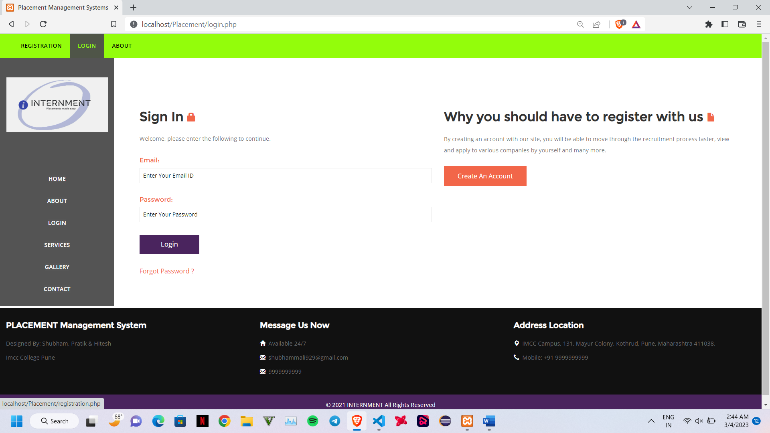

Create User Profile:

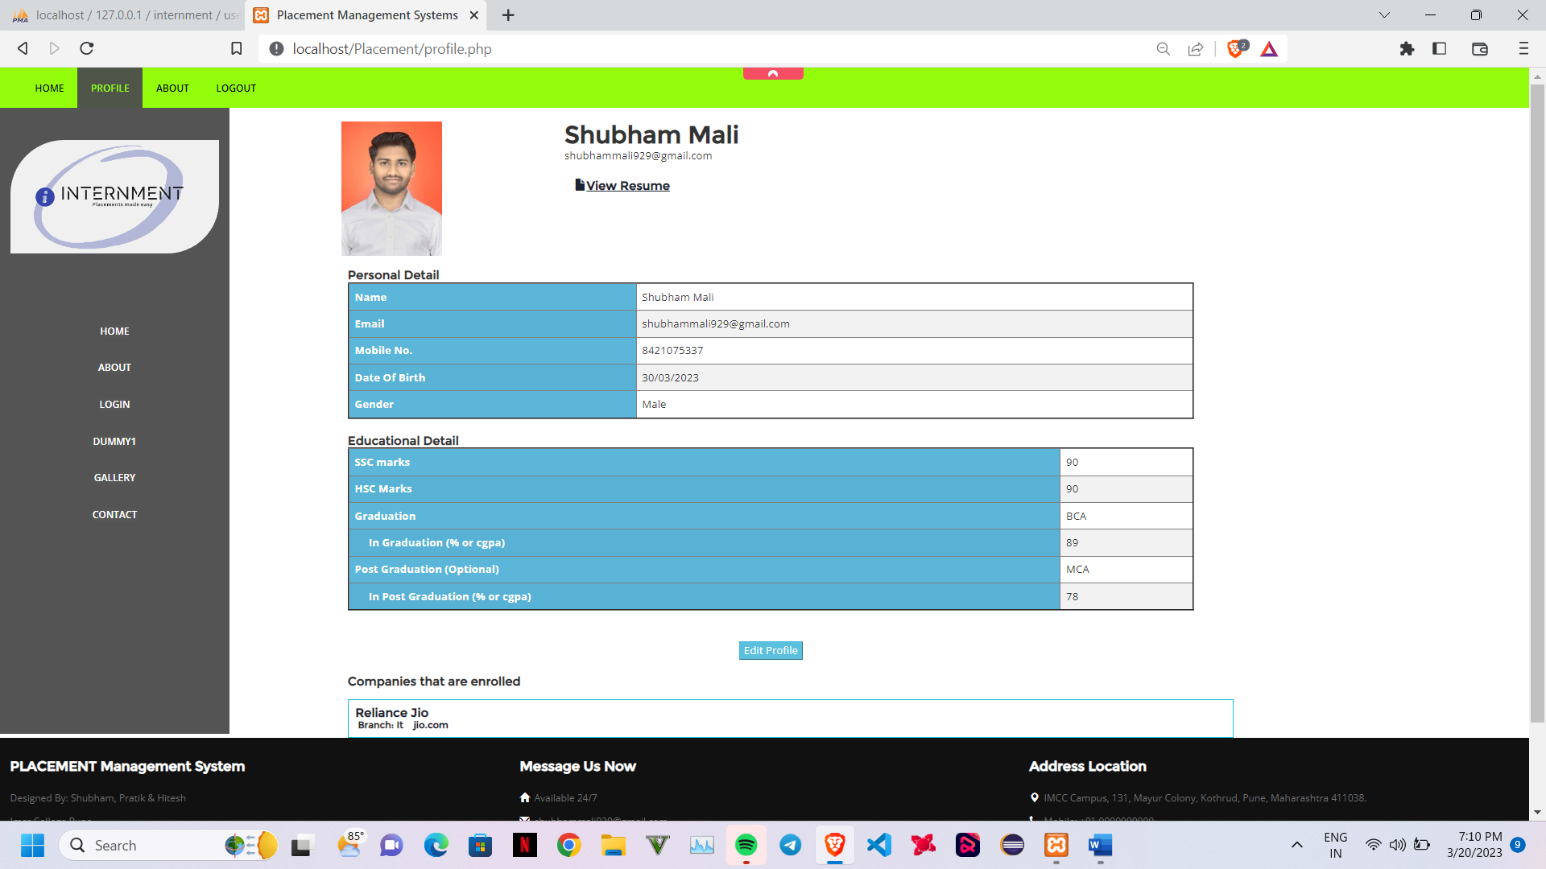

User DashBoard/Home:

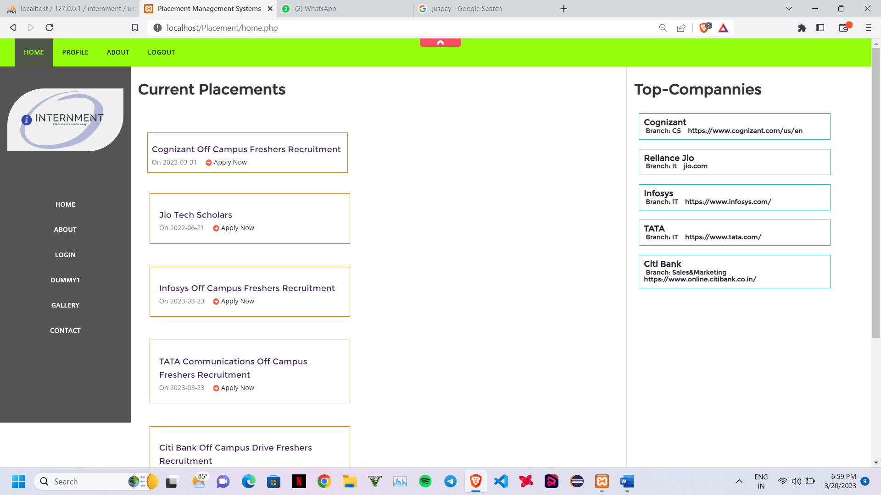

Job Details:

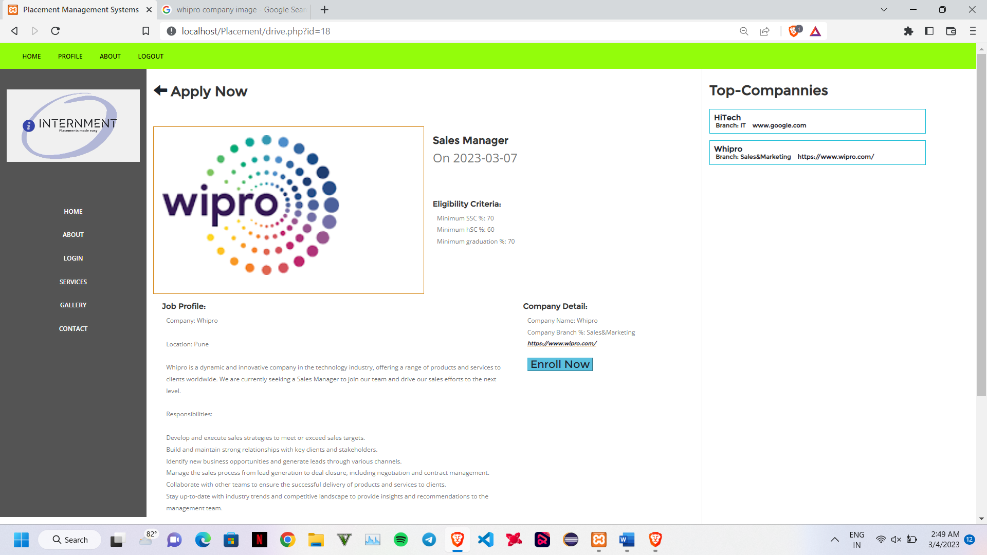

Add Company:

Add Drive:

All Drives:

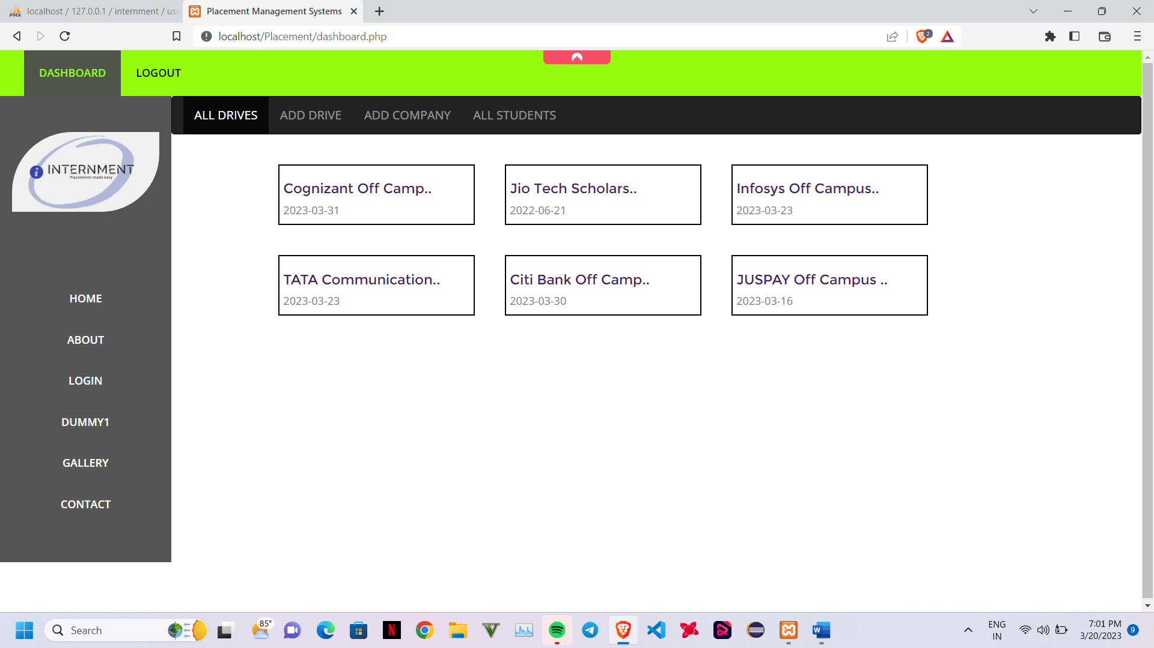

All Applications:

Profile of applied Students

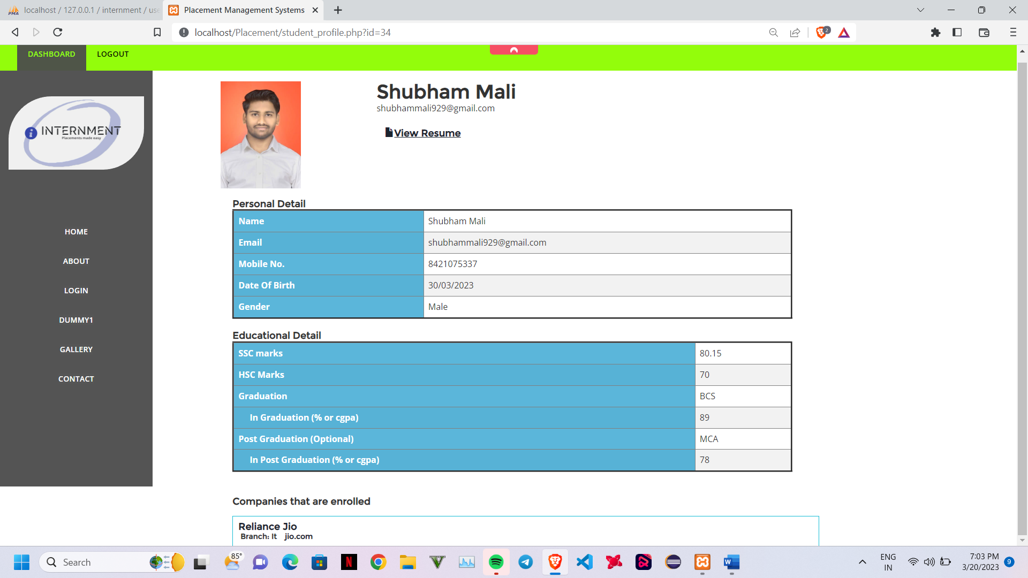

**4.0 CODE**

**Login.php**

<?php

include "includes/header.php";

if(isset($_SESSION['admin'])){

    header("Location: dashboard.php");

}

if(isset($_SESSION['name'])&&isset($_SESSION['email'])){

    header("Location: profile.php");

}

$set_value = 0;

$error = '0';

if(isset($_REQUEST['email'])&&isset($_REQUEST['pass'])){

    $email = trim($_REQUEST['email']);

    $pass = trim($_REQUEST['pass']);

    if($email=="admin@gmail.com"&&$pass=="admin"){

        $_SESSION['admin'] = true;

        header("Location: dashboard.php");

    }

    $pass = md5(trim($_REQUEST['pass']));

    $sql = "SELECT *

               FROM users

               WHERE user_email='$email'

               AND user_pass='$pass'";

    $result = mysqli_query($con, $sql);

    $num_rows = mysqli_num_rows($result);

    if($num_rows>0){

        $row = mysqli_fetch_array($result);

        $_SESSION['id'] = $row['user_id'];

        $_SESSION['name'] = $row['user_name'];

        $_SESSION['email'] = $row['user_email'];

        header("Location: home.php");

    } else{

        $set_value = 1;

        $error = "Invalid Email or Password";

    }

}

?>

<div class="col-md-9 main">

    <!-- login-page -->

    <div class="login">

        <div class="login-grids">

            <div class="col-md-6 log">

                     <h3 class="tittle" id = "signin">Sign In <i class="glyphicon glyphicon-lock"></i></h3>

                     <p id="login_instructions" style="display: block">Welcome, please enter the following to continue.</p>

            <?php

            if($set_value==1){

                echo '<div id="error" style="display: block;">

                        <div class="alert alert-danger" role="alert"">

                        <i class="glyphicon glyphicon-lock"></i>

                        <strong>Error! : </strong> <span id="error_message">'.$error.'</span>

                        </div>

                        </div>';

            }

            ?>

                    <div id = "form-area" style="display: block">

                         <form id = "form" method="post" action="login.php">

                             <h5>Email:</h5>

                             <input type="email" name="email" value="" id="input-email" placeholder="Enter Your Email ID" required>

                             <h5>Password:</h5>

                             <input type="password" name="pass" value="" id="input-pass" placeholder="Enter Your Password" required>

                             <input type="submit" value="Login" id="input-submit" style="display: block">

                         </form>

                        <a href="#">Forgot Password ?</a>

                    </div>

            </div>

            <div class="col-md-6 login-right">

                <h3 class="tittle">Why you should have to register with us <i class="glyphicon glyphicon-file"></i></h3>

                <p>By creating an account with our site, you will be able to move through the recruitment process faster,

                    view and apply to various companies by yourself and many more.</p>

                <a href="registration.php" class="hvr-bounce-to-bottom button">Create An Account</a>

            </div>

            <div class="clearfix"></div>

        </div>

    </div>

</div>

<!-- //login-page -->

            <div class="clearfix"> </div>

<?php

include "includes/footer.php";

?>

**Logout.php**

<?php

session_start();

unset($_SESSION['id']);

unset($_SESSION['name']);

unset($_SESSION['email']);

unset($_SESSION['admin']);

header("Location: login.php");

?>

**5.0 Bibilography**

* Reference Websites:

[www.w3school.com](http://www.w3school.com)

[www.stackoverflow.com](http://www.stackoverflow.com)

[www.google.com](http://www.google.com)

[www.udemy.com](http://www.udemy.com)

<https://lucid.app.com>

<https://chat.openai.com/chat>

**5.1 Future Enhancements:**

* Automatic resume builder
* Search functionalitiy
* Sorting drives companywise
* Application Status
* User Application History
* Forgot password